https://developer.mozilla.org/en-US/docs/Learn:

Learn web development
Welcome to the MDN Learning Area. This set of articles aims to provide complete beginners to web development with all they need to start coding simple websites.
The aim of this area of MDN is not to take you from "beginner" to "expert" but to take you from "beginner" to "comfortable". From there you should be able to start making your own way, learning from the rest of MDN and other intermediate to advanced resources that assume a lot of previous knowledge.
If you are a complete beginner, web development can be challenging — we will hold your hand and provide enough detail for you to feel comfortable and learn the topics properly. You should feel at home whether you are a student learning web development (on your own or as part of a class), a teacher looking for class materials, a hobbyist, or someone who just wants to understand more about how web technologies work.

Where to Start
Complete beginner: | Specific questions: | Beyond the basics: | Moving onto scripting
If you are a complete beginner to web development, we'd recommend that you start by working through our Getting started with the Web module, which provides a practical introduction to web development. | If you have a specific question about web development, our Common questions section may have something to help you. | If you have a bit of knowledge already, the next step is to learn HTML and CSS in detail: start with our Introduction to HTML module and move on to our Introduction to CSS module. | If you are comfortable with HTML and CSS already, or you are mainly interested in coding, you'll want to move onto JavaScript or server-side development. Begin with our JavaScript first steps and Server-side first steps modules.

Topics Covered
The following is a list of all the topics we cover in the MDN learning area.
Getting started with the web
Provides a practical introduction to web development for complete beginners.
HTML — Structuring the web
HTML is the language that we use to structure the different parts of our content and define what their meaning or purpose is. This topic teaches HTML in detail.
CSS — Styling the web
CSS is the language that we can use to style and lay out our web content, as well as adding behavior like animation. This topic provides comprehensive coverage of CSS.
JavaScript — Dynamic client-side scripting
JavaScript is the scripting language used to add dynamic functionality to web pages. This topic teaches all the essentials needed to become comfortable with writing and understanding JavaScript.
Accessibility — make the web usable by everyone
Accessibility is the practice of making web content available to as many people as possible regardless of disability, device, locale, or other differentiating factors. This topic gives you all you need to know.
Tools and testing
This topic is a place to cover tools developers use to facilitate their work, such as cross browser testing tools.
Server-side website programming
Even if you are concentrating on client-side web development, it is still useful to know about how servers and server-side code features work. This topic provides a general introduction to how the server-side works, and detailed tutorials detailing how to build up a server-side app using two popular frameworks — Django (Python) and Express (node.js).

Getting Our Code Example
The code examples you'll encounter in the Learning Area are all available on GitHub. If you want to copy them all to your computer, the easiest way is to:
- Install Git on your machine. This is the underlying version control system software that GitHub works on top of.
- Sign up for a GitHub account. It's simple and easy.
- Once you've signed up, log in to github.com with your username and password.
- Open your computer's command prompt (Windows) or terminal (Linux, MacOSX)
- To copy the learning area repo to a folder called learning-area in the current location your command prompt/terminal is pointing to, use the following command:
git clone https://github.com/mdn/learning-area
- You can now enter the directory and find the files you are after (either using your finder/file explorer or the cd command).
You can update the learning-area repository with any changes made to the master version on GitHub with the following steps:
- In your command prompt/terminal, go inside the learning-area directory using cd. For example, if you were in the parent directory:
cd learning-area
- Update the repository using the following command:
git pull

Conract Us
If you want to get in touch with us about anything, the best way is to drop us a message on our Learning Area discourse thread or IRC channels. We'd like to hear from you about anything you think is wrong or missing on the site, requests for new learning topics, requests for help with items you don't understand, or any other questions or concerns.
If you're interested in helping develop/improve the content, take a look at how you can help, and get in touch! We are more than happy to talk to you, whether you are a learner, teacher, experienced web developer, or someone else interested in helping to improve the learning experience.

See Also
Mozilla Developer Newsletter
Our newsletter for web developers, which is a great resource for all levels of experience.
Codecademy
A great interactive site for learning programming languages from scratch.
Code.org
Basic coding theory and practice, mainly aimed at children/complete beginners.
freeCodeCamp.org
Interactive site with tutorials and projects to learn web development.
Web Literacy Map
A framework for entry-level web literacy & 21st Century skills, which also provides access to teaching activities sorted by category.
Teaching activities
A series of teaching activities for teaching (and learning) created by the Mozilla Foundation, covering everything from basic web literacy and privacy to JavaScript and hacking Minecraft.

Getting Started with the WEB
Getting started with the Web is a concise series introducing you to the practicalities of web development. You'll set up the tools you need to construct a simple webpage and publish your own simple code.

The story of your first website
It's a lot of work to create a professional website, so if you're new to web development we encourage you to start small. You won't build another Facebook right away, but it's not hard to get your own simple website online, so we'll start there.
By working through the articles listed below in order, you will go from nothing to getting your first webpage online. Let's go!

Installing basic software
When it comes to tools for building a website, there's a lot to pick from. If you're just starting out, you might be confused by the array of code editors, frameworks, and testing tools out there. In Installing basic software we show you step-by-step how to install just the software you need to begin some basic web development.
In Installing basic software, we show you what tools you need to do simple web development, and how to install them properly.

What tools do the professionals use?
- A computer. Maybe that sounds obvious to some people, but some of you are reading this article from your phone or a library computer. For serious web development, it's better to invest in a desktop or laptop computer (Windows, Mac, or Linux).
- A text editor, to write code in. This could be a text editor (e.g. Brackets, Atom or Visual Studio Code), or a hybrid editor (e.g. Dreamweaver). Office document editors are not suitable for this use, as they rely on hidden elements that interfere with the rendering engines used by web browsers.
- Web browsers, to test code in. Currently the most-used browsers are Firefox, Chrome, Opera, Safari, Internet Explorer and Microsoft Edge. You should also test how your site performs on mobile devices and on any old browsers your target audience may still be using extensively (such as IE 8–10.)
- A graphics editor, like GIMP, Paint.NET, or Photoshop, to make images for your webpages.
- A version control system, to manage files on servers, collaborate on a project with a team, share code and assets, and avoid editing conflicts. Right now Git is the most popular version control tool, and the GitHub code hosting service, based on Git, is also very popular.
- A FTP program, used on older webhosting accounts to manage files on servers (Git is increasingly replacing FTP for this purpose). There are loads of (S)FTP programs available including Cyberduck, Fetch, and FileZilla.
- An automation system like Grunt or Gulp to automatically perform repetitive tasks, such as minifying code and running tests.
- Templates, libraries, frameworks, etc., to speed up writing common functionality.
- More tools besides!

What tools do I actually need right now?
That looks like a scary list, but fortunately you can get started in web development without knowing anything about most of these. In this article we'll just set you up with a bare minimum — a text editor and some modern web browsers.

Installing a text editor
You probably already have a basic text editor on your computer. By default Windows includes Notepad and macOS comes with TextEdit. Linux distros vary; Ubuntu comes with gedit by default.
For web development, you can probably do better than Notepad or TextEdit. We recommend starting out with Brackets, which is a free editor that offers live previews and code hints.

Installing modern web browser
For now, we'll just install a couple of desktop web browsers to test our code in. Choose your operating system below and click the relevant links to download installers for your favorite browsers:
- Linux: Firefox, Chrome, Opera.
- Windows: Firefox, Chrome, Opera, Internet Explorer, Microsoft Edge (Windows 10 comes with Edge by default; if you have Windows 7 or above, you can install Internet Explorer 11; otherwise, you should install an alternative browser)
- Mac: Firefox, Chrome, Opera, Safari (Safari comes with iOS and macOS by default)
Before going on, you should install at least two of these browsers and have them ready for testing.

Installing a local web server
Some examples will need to be run through a web server to work successfully. You can find out how to do this in How do you set up a local testing server?

How do you set up a local testing server?
This article explains how to set up a simple local testing server on your machine, and the basics of how to use it.

Local files versus remote files
Throughout most of the learning area, we tell you to just open your examples directly in a browser — this is done by double clicking the HTML file, or dragging and dropping it into the browser window, or choosing File > Open... and navigating to the HTML file, etc. There are many ways to achieve this.
You know if you are running the example from a local file because the web address will have file:// at the start of it, followed by the path to the file on your local hard drive. In contrast, if you view one of our examples hosted on GitHub (or an example on some other remote server), the web address will have http:// or https:// at the start of it, to show that the file has been received via HTTP.

The problem with testing local files
Some examples won't run if you open them as local files. This can be due to a variety of reasons, the most likely being:
- They feature asynchronous requests. Some browsers (including Chrome) will not run async requests (see Fetching data from the server) if you just run the example from a local file. This is because of security restrictions (for more on web security, read Website security).
- They feature a server-side language. Server-side languages (such as PHP or Python) require a special server to interpret the code and deliver the results.

Running a simple local HTTP server
To get around the problem of async requests, we need to test such examples by running them through a local web server. One of the easiest ways to do this for our purposes is to use Python's SimpleHTTPServer module.
To do this:
- Install Python. If you are using Linux or Mac OS X, it should be available on your system already. If you are a Windows user, you can get an installer from the Python homepage and follow the instructions to install it:
  - Go to python.org
  - Under the Download section, click the link for Python "3.xxx".
  - At the bottom of the page, choose the Windows x86 executable installer and download it.
  - When it has downloaded, run it.
  - On the first installer page, make sure you check the "Add Python 3.xxx to PATH" checkbox.
  - Click Install, then click Close when the installation has finished.
- Open your command prompt (Windows)/terminal (OS X/Linux). To check Python is installed, enter the following command:
python -V
- This should return a version number. If this is OK, navigate to the directory that your example is inside, using the cd command.
# include the directory name to enter it, for example
cd Desktop
# use two dots to jump up one directory level if you need to
cd ..
  - Enter the command to start up the server in that directory:
# If Python version returned above is 3.X
python -m http.server
# If Python version returned above is 2.X
python -m SimpleHTTPServer
  - By default, this will run the contents of the directory on a local web server, on port 8000. You can go to this server by going to the URL localhost:8000 in your web browser. Here you'll see the contents of the directory listed — click the HTML file you want to run.
Note: If you already have something running on port 8000, you can choose another port by running the server command followed by an alternative port number, e.g. python -m http.server 7800 (Python 3.x) or python -m SimpleHTTPServer 7800 (Python 2.x). You can then access your content at localhost:7800.

Running server-side languages locally
Python's SimpleHTTPServer module is useful, but it doesn't know how to run code written in languages such as PHP or Python. To handle that you'll need something more — exactly what you'll need depends on the server-side language you are trying to run. Here are a few examples:
- To run Python server-side code, you'll need to use a Python web framework. You can find out how to use the Django framework by reading Django Web Framework (Python). Flask is also a good (slightly less heavyweight) alternative to Django. To run this you'll need to install Python/PIP, then install Flask using pip3 install flask. At this point you should be able to run the Python Flask examples using for example python3 python-example.py, then navigating to localhost:5000 in your browser.
- To run Node.js (JavaScript) server-side code, you'll need to use raw node or a framework built on top of it. Express is a good choice — see Express Web Framework (Node.js/JavaScript).
- To run PHP server-side code, you'll need a server setup that can interpret PHP. Good options for local PHP testing are MAMP (Mac and Windows) , AMPPS (Mac, Windows, Linux) and LAMP (Linux, Apache, MySQL, and PHP/Python/Perl). These are complete packages that create local setups to allow you to run the Apache server, PHP, and MySQL databases.

What will your website look like?
Before you start writing the code for your website, you should plan it first. What information are you showcasing? What fonts and colors are you using? What will your website look like? We outline a simple method you can follow to plan out your site's content and design.
What will your website look like? discusses the planning and design work you have to do for your website before writing code, including "What information does my website offer?", "What fonts and colors do I want?", and "What does my site do?"

First thing first: planning
Before you do anything, you need some ideas. What should your website actually do? A website can do basically anything, but for your first try you should keep things simple. We'll start by creating a simple webpage with a heading, an image, and a few paragraphs.
To begin with, you'll need to answer these questions:
- What is your website about? Do you like dogs, New York, or Pacman?
- What information are you presenting on the subject? Write a title and a few paragraphs, and think of an image you'd like to show on your page.
- What does your website look like, in simple high-level terms? What's the background color? What kind of font is appropriate: formal, cartoony, bold and loud, subtle?
- Note: Complex projects need detailed guidelines that go into all the details of colors, fonts, spacing between items on a page, appropriate writing style, and so on. This is sometimes called a design guide or a brand book, and you can see an example at the Firefox OS Guidelines.

Sketching out your design
Next, get a pen and paper and sketch out roughly how you want your site to look. For your first simple webpage, there's not much to sketch out, but you should get in the habit of doing this now. It really helps — you don't have to be Van Gogh!
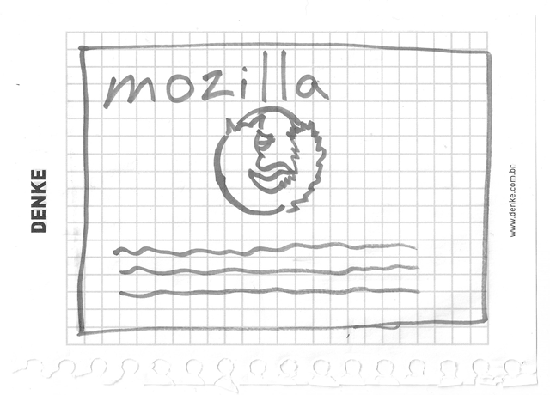
- Note: Even on real, complex websites, the design teams usually start out with rough sketches on paper and later on build digital mockups using a graphics editor or web technologies.
- Note: Web teams often include both a graphic designer and a user-experience (UX) designer. Graphic designers, obviously, put together the visuals of the website. UX designers have a somewhat more abstract

Choosing your assets
At this point, it's good to start putting together the content that will eventually appear on your webpage.

Text
You should still have your paragraphs and title from earlier. Keep these close by.

Theme color
To choose a color, go to the Color Picker and find a color you like. When you click on a color, you'll see a strange six-character code like #660066. That's called a hex(adecimal) code, and represents your color. Copy the code down somewhere safe for now.
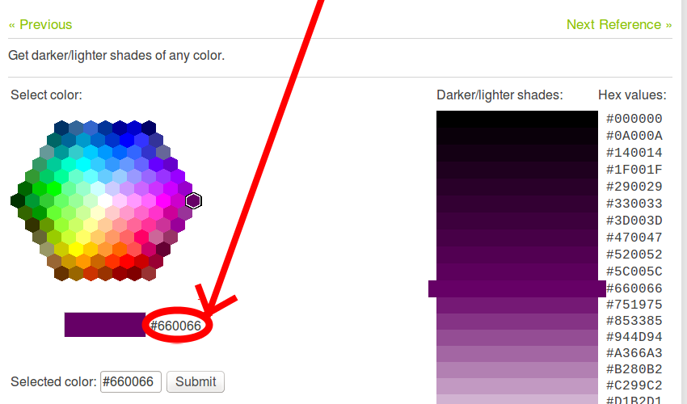

Images
To choose an image, go to Google Images and search for something suitable.
- When you find the image you want, click on the image.
- Press the View image button.
- On the next page, right-click the image (Ctrl + click on a Mac), choose Save Image As..., and choose a safe place to save your image. Alternatively, copy the image's web address from your browser's address bar for later use.
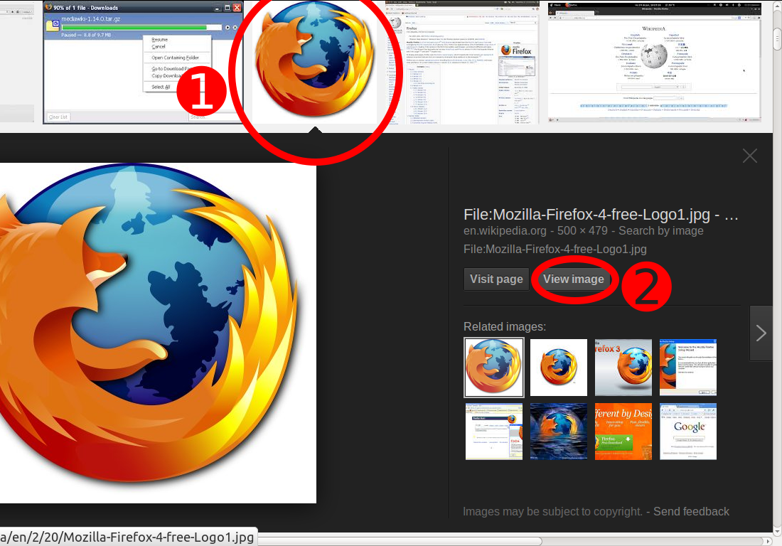
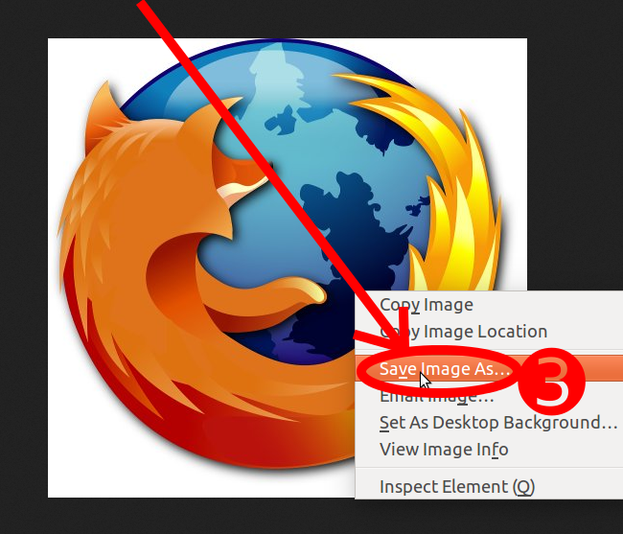
- Note: Most images on the web, including in Google Images, are copyrighted. To reduce your likelihood of violating copyright, you can use Google's license filter. Just 1) click on Search tools, then on 2) Usage rights: 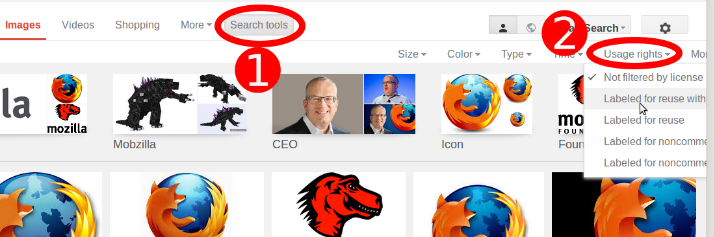

Font
To choose a font:
- Go to Google Fonts and scroll down the list until you find one you like. You can also use the controls on the right to further filter the results.
- Click the "plus" (Add to) icon next to the font you want.
- Click the "* Family Selected" button in the panel at the bottom of the page ("*" depends on how many fonts you selected).
- In the popup box, you can see and copy the lines of code Google gives you into your text editor to save for later.
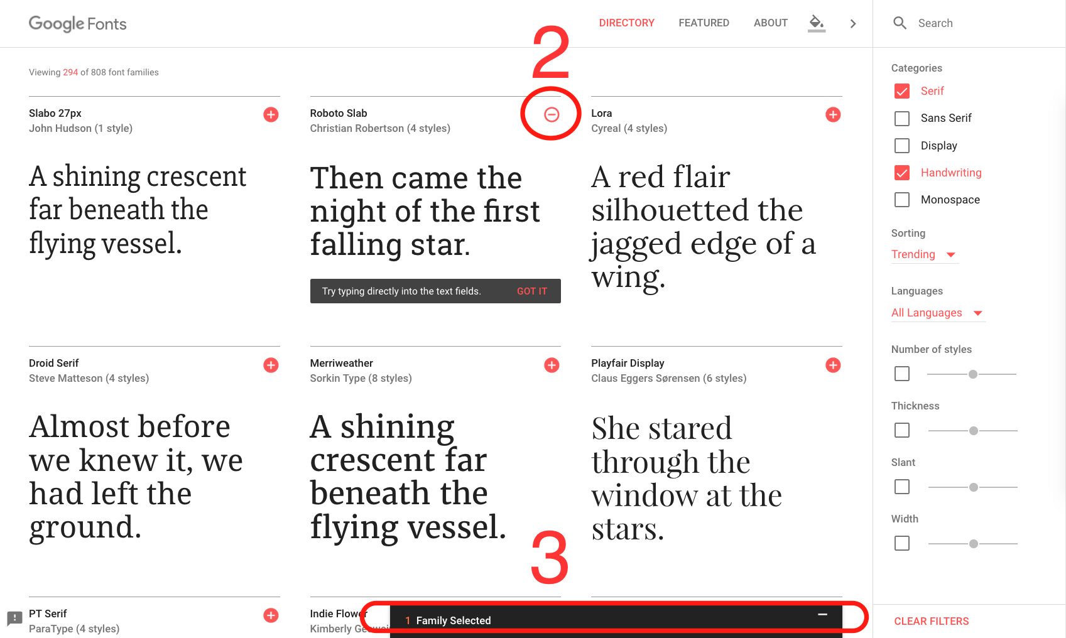
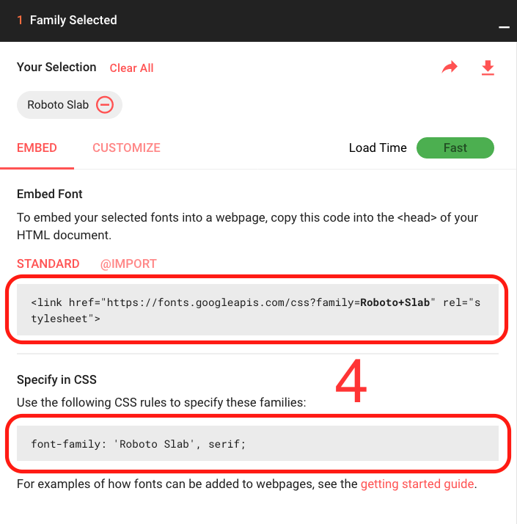

Dealing with files
A website consists of many files: text content, code, stylesheets, media content, and so on. When you're building a website, you need to assemble these files into a sensible structure and make sure they can talk to one another. Dealing with files explains how to set up a sensible file structure for your website and what issues you should be aware of.
A website consists of many files: text content, code, stylesheets, media content, and so on. When you're building a website, you need to assemble these files into a sensible structure on your local computer, make sure they can talk to one another, and get all your content looking right, before you eventually upload them to a server. Dealing with files discusses some issues you should be aware of so you can set up a sensible file structure for your website.

Where should your website live on your computer?
When you are working on a website locally on your own computer, you should keep all the related files in a single folder that mirrors the published website's file structure on the server. This folder can live anywhere you like, but you should put it somewhere where you can easily find it, maybe on your Desktop, in your Home folder, or at the root of your hard drive.
- Choose a place to store your website projects. Here, create a new folder called web-projects (or similar). This is where all your website projects will live.
- Inside this first folder, create another folder to store your first website in. Call it test-site (or something more imaginative).

An aside on casing and spacing
You'll notice that throughout this article, we ask you to name folders and files completely in lowercase with no spaces. This is because:
- Many computers, particularly web servers, are case-sensitive. So for example, if you put an image on your website at test-site/MyImage.jpg, and then in a different file you try to invoke the image as test-site/myimage.jpg, it may not work.
- Browsers, web servers, and programming languages do not handle spaces consistently. For example, if you use spaces in your filename, some systems may treat the filename as two filenames. Some servers will replace the spaces in your filenames with "%20" (the character code for spaces in URIs), breaking all your links. It's better to separate words with dashes, rather than underscores: my-file.html vs. my_file.html.
The short answer is that you should use a hyphen for your file names. The Google search engine treats a hyphen as a word separator, but does not treat an underscore that way. For these reasons, it is best to get into the habit of writing your folder and file names lowercase with no spaces and with words separated by dashes, at least until you know what you're doing. That way you'll bump into fewer problems later down the road.

What structure should your website have?
Next, let's look at what structure our test site should have. The most common things we'll have on any website project we create are an index HTML file and folders to contain images, style files, and script files. Let's create these now:
- index.html: This file will generally contain your homepage content, that is, the text and images that people see when they first go to your site. Using your text editor, create a new file called index.html and save it just inside your test-site folder.
- images folder: This folder will contain all the images that you use on your site. Create a folder called images, inside your test-site folder.
- styles folder: This folder will contain the CSS code used to style your content (for example, setting text and background colors). Create a folder called styles, inside your test-site folder.
- scripts folder: This folder will contain all the JavaScript code used to add interactive functionality to your site (e.g. buttons that load data when clicked). Create a folder called scripts, inside your test-site folder.
- Note: On Windows computers, you might have trouble seeing the file names, because Windows has an option called Hide extensions for known file types turned on by default. Generally you can turn this off by going to Windows Explorer, selecting the Folder options... option, unchecking the Hide extensions for known file types checkbox, then clicking OK. For more specific information covering your version of Windows, do a web search!

File paths
To make files talk to one another, you have to provide a file path between them — basically a route so one file knows where another one is. To demonstrate this, we will insert a little bit of HTML into our index.html file, and make it display the image you chose in the article "What will your website look like?"
- Copy the image you chose earlier into your images folder.
- Open up your index.html file, and insert the following code into the file exactly as shown. Don't worry about what it all means for now — we'll look at the structures in more detail later in the series.
- <!DOCTYPE html>
- <html>
- <head>
- <meta charset="utf-8">
- <title>My test page</title>
- </head>
- <body>
- <img src="" alt="My test image">
- </body>
- </html>
- The line <img src="" alt="My test image"> is the HTML code that inserts an image into the page. We need to tell the HTML where the image is. The image is inside the images directory, which is in the same directory as index.html. To walk down the file structure from index.html to our image, the file path we'd need is images/your-image-filename. For example, our image is called firefox-icon.png, so the file path is images/firefox-icon.png.
- Insert the file path into your HTML code between the double quote marks of the src="" code.
- Save your HTML file, then load it in your web browser (double-click the file). You should see your new webpage displaying your image!
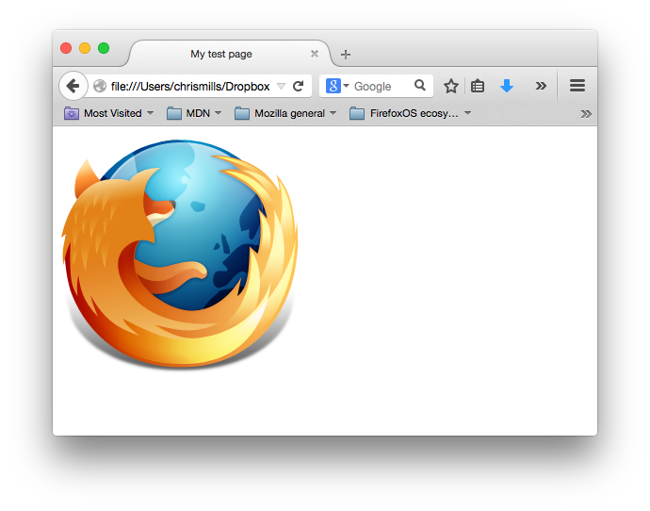
Some general rules for file paths:
- To link to a target file in the same directory as the invoking HTML file, just use the filename, e.g. my-image.jpg.
- To reference a file in a subdirectory, write the directory name in front of the path, plus a forward slash, e.g. subdirectory/my-image.jpg.
- To link to a target file in the directory above the invoking HTML file, write two dots. So for example, if index.html was inside a subfolder of test-site and my-image.jpg was inside test-site, you could reference my-image.jpg from index.html using ../my-image.jpg.
- You can combine these as much as you like, for example ../subdirectory/another-subdirectory/my-image.jpg.
For now, this is about all you need to know.
- Note: The Windows file system tends to use backslashes, not forward slashes, e.g. C:\windows. This doesn't matter in HTML — even if you are developing your website on Windows, you should still use forward slashes in your code.

What else shouls be done?
That is about it for now. Your folder structure should look something like this:
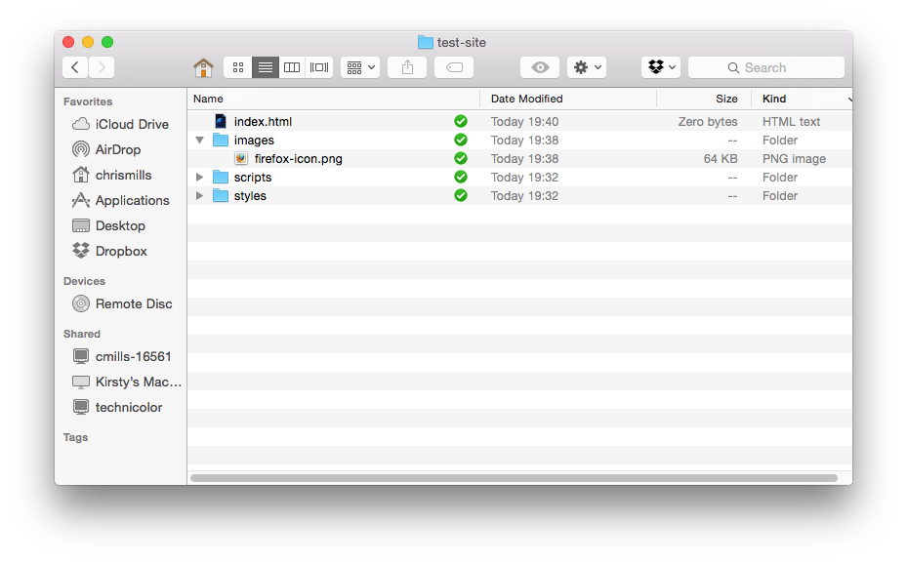

HTML basics
Hypertext Markup Language (HTML) is the code that you use to structure your web content and give it meaning and purpose. For example, is my content a set of paragraphs, or a list of bullet points? Do I have images inserted in my page? Do I have a data table? Without overwhelming you, HTML basics provides enough information to make you familiar with HTML.
HTML (Hypertext Markup Language) is the code that is used to structure a web page and its content. For example, content could be structured within a set of paragraphs, a list of bulleted points, or using images and data tables. As the title suggests, this article will give you a basic understanding of HTML and what its function is.

So what is HTML, really?
HTML is not a programming language; it is a markup language, and is used to tell your browser how to display the webpages you visit. It can be as complicated or as simple as the web designer wishes it to be. HTML consists of a series of elements, which you use to enclose, or wrap, different parts of the content to make it appear a certain way, or act a certain way. The enclosing tags can make a word or an image a hyperlink to somewhere else, can italicize words, and can make font bigger or smaller, and so on. For example, take the following line of content:
  - My cat is very grumpy

If we wanted the line to stand by itself, we could specify that it is a paragraph by enclosing it in paragraph tags:
    - <p>My cat is very grumpy</p>

Anatomy of an HTML element
Let's explore this paragraph element a bit further.
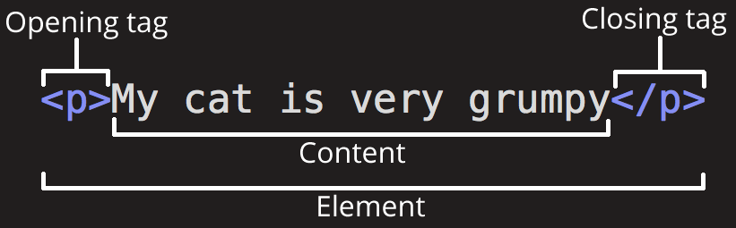
The main parts of our element are:
- The opening tag: This consists of the name of the element (in this case, p), wrapped in opening and closing angle brackets. This states where the element begins, or starts to take effect — in this case where the start of the paragraph is.
- The closing tag: This is the same as the opening tag, except that it includes a forward slash before the element name. This states where the element ends — in this case where the end of the paragraph is. Failing to include a closing tag is one of the common beginner errors and can lead to strange results.
- The content: This is the content of the element, which in this case is just text.
- The element: The opening tag plus the closing tag plus the content equals the element.
Elements can also have attributes, which look like this:
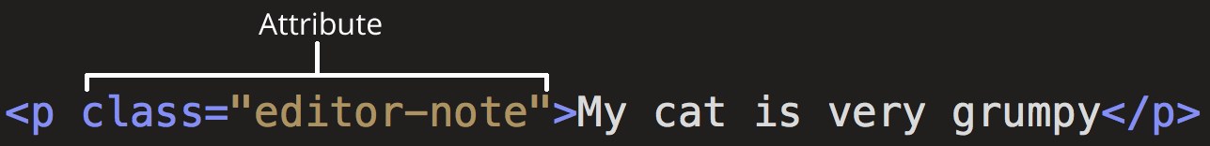
Attributes contain extra information about the element that you don't want to appear in the actual content. Here, class is the attribute name, and editor-note is the attribute value. The class attribute allows you to give the element an identifier that can be later used to target the element with style information and other things.
An attribute should always have:
- A space between it and the element name (or the previous attribute, if the element already has one or more attributes).
- The attribute name, followed by an equals sign.
- Opening and closing quote marks wrapped around the attribute value.

Nesting elements
You can put elements inside other elements too — this is called nesting. If we wanted to state that our cat is very grumpy, we could wrap the word "very" in a <strong> element, which means that the word is to be strongly emphasized:
<p>My cat is <strong>very</strong> grumpy.</p>
You do however need to make sure that your elements are properly nested: in the example above we opened the <p> element first, then the <strong> element, therefore we have to close the <strong> element first, then the <p>. The following is incorrect:
<p>My cat is <strong>very grumpy.</p></strong>

The elements have to open and close correctly so they are clearly inside or outside one another. If they overlap like above, then your web browser will try to make a best guess at what you were trying to say, and you may well get unexpected results. So don't do it!

Empty elements
Some elements have no content, and are called empty elements. Take the <img> element we already have in our HTML:
<img src="images/firefox-icon.png" alt="My test image">

This contains two attributes, but there is no closing </img> tag, and no inner content. This is because an image element doesn't wrap content to have an effect on it. Its purpose is to embed an image in the HTML page in the place it appears.

Anatomy of an HTML document
That wraps up the basics of individual HTML elements, but they aren't very useful on their own. Now we'll look at how individual elements are combined to form an entire HTML page. Let's revisit the code we put into our index.html example (which we first met in the Dealing with files article):
<!DOCTYPE html>
<html>
<head>
<meta charset="utf-8">
<title>My test page</title>
</head>
<body>
<img src="images/firefox-icon.png" alt="My test image">
</body>
</html>

Here we have:
- <!DOCTYPE html> — the doctype. In the mists of time, when HTML was young (about 1991/2), doctypes were meant to act as links to a set of rules that the HTML page had to follow to be considered good HTML, which could mean automatic error checking and other useful things. However, these days no one really cares about them, and they are really just a historical artefact that needs to be included for everything to work right. For now, that's all you need to know.
- <html></html> — the <html> element. This element wraps all the content on the entire page, and is sometimes known as the root element.
- <head></head> — the <head> element. This element acts as a container for all the stuff you want to include on the HTML page that isn't the content you are showing to your page's viewers. This includes things like keywords and a page description that you want to appear in search results, CSS to style our content, character set declarations, and more.
- <body></body> — the <body> element. This contains all the content that you want to show to web users when they visit your page, whether that's text, images, videos, games, playable audio tracks, or whatever else.
- <meta charset="utf-8"> — this element sets the character set your document should use to UTF-8, which includes most characters from the vast majority of human written languages. Essentially it can now handle any textual content you might put on it. There is no reason not to set this, and it can help avoid some problems later on.
- <title></title> — the <title> element. This sets the title of your page, which is the title that appears in the browser tab the page is loaded in. It is also used to describe the page when you bookmark/favourite it.

Images
Let's turn our attention to the <img> element again:
<img src="images/firefox-icon.png" alt="My test image">
As we said before, it embeds an image into our page in the position it appears. It does this via the src (source) attribute, which contains the path to our image file.
We have also included an alt (alternative) attribute. In this attribute, you specify descriptive text for users who cannot see the image, possibly because:
- They are visually impaired. Users with significant visual impairments often use tools called screen readers to read out the alt text to them.
- Something has gone wrong causing the image to not display. For example, try deliberately changing the path inside your src attribute to make it incorrect. If you save and reload the page, you should see something like this in place of the image:
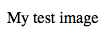
The key words about alt text are "descriptive text". The alt text you write should provide the reader with enough information to have a good idea of what the image conveys. In this example, our current text of "My test image" is no good at all. A much better alternative for our Firefox logo would be "The Firefox logo: a flaming fox surrounding the Earth."
Try coming up with some better alt text for your image now.
- Note: Find out more about accessibility at MDN's Accessibility landing page.

Marking up text
This section will cover some of the basic HTML elements you'll use for marking up text.

Headings
Heading elements allow you to specify that certain parts of your content are headings — or subheadings — of your content. In the same way that a book has a main title, chapter titles and subtitles, an HTML document can too. HTML contains six heading levels, <h1>–<h6> although you'll commonly only use 3–4 at most:
<h1>My main title</h1>
<h2>My top level heading</h2>
<h3>My subheading</h3>
<h4>My sub-subheading</h4>

Now try adding a suitable title to your HTML page just above your <img> element.

Paragraphs
As explained above, <p> elements are for containing paragraphs of text; you'll use these frequently when marking up regular text content:
<p>This is a single paragraph</p>
Add your sample text (you should have it from What should your website look like?) into one or a few paragraphs, placed directly below your <img> element.

Lists
A lot of the web's content is lists, and HTML has special elements for these. Marking up lists always consist of at least two elements. The most common list types are ordered and unordered lists:
- Unordered lists are for lists where the order of the items doesn't matter, like a shopping list. These are wrapped in a <ul> element.
- Ordered lists are for lists where the order of the items does matter, like a recipe. These are wrapped in an <ol> element.
Each item inside the lists is put inside an <li> (list item) element.
For example, if we wanted to turn the part of the following paragraph fragment into a list:
<p>At Mozilla, we’re a global community of technologists, thinkers, and builders working together ... </p>

We could modify the markup to this:
<p>At Mozilla, we’re a global community of</p>

<ul>
<li>technologists</li>
<li>thinkers</li>
<li>builders</li>
</ul>

<p>working together ... </p>
Try adding an ordered or unordered list to your example page.

Links
Links are very important — they are what makes the web a web! To add a link, we need to use a simple element — <a> — the "a" being short for "anchor". To make text within your paragraph into a link, follow these steps:
- Choose some text. We chose the text "Mozilla Manifesto".
- Wrap the text in an <a> element, like so:
<a>Mozilla Manifesto</a>
- Give the <a> element an href attribute, like so:
<a href="">Mozilla Manifesto</a>
- Fill in the value of this attribute with the web address that you want the link to link to:
<a href="https://www.mozilla.org/en-US/about/manifesto/">Mozilla Manifesto</a>
You might get unexpected results if you omit the https:// or http:// part, called the protocol, at the beginning of the web address. After making a link, click it to make sure it is sending you where you wanted it to.
- href might appear like a rather obscure choice for an attribute name at first. If you are having trouble remembering it, remember that it stands for hypertext reference.
Add a link to your page now, if you haven't already done so.

Conclusion
If you have followed all the instructions in this article, you should end up with a page that looks like the one below (you can also view it here):
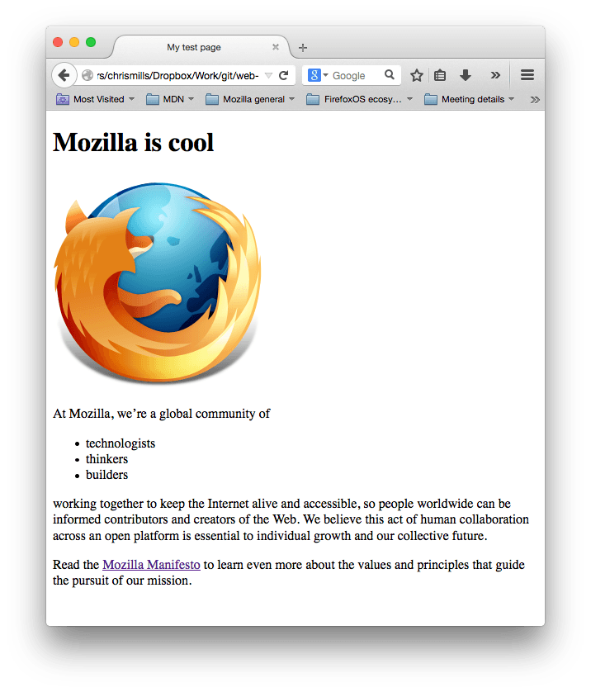
If you get stuck, you can always compare your work with our finished example code on GitHub.
Here, we have only really scratched the surface of HTML. To find out more, go to our HTML Learning topic.

Multimedia and embedding
We've looked at a lot of text so far in this course, but the web would be really boring only using text. Let's start looking at how to make the Web come alive, with more interesting content! This module explores how to use HTML to include multimedia in your web pages, including the different ways that images can be included, and how to embed video, audio, and even entire webpages.

Prerequisites
Before starting this module, you should have a reasonable knowledge of the basics of HTML, as previously covered in Introduction to HTML. If you've not worked through this module (or something similar), work through it first, then come back!
- Note: If you are working on a computer/tablet/other device where you don't have the ability to create your own files, you could try out (most of) the code examples in an online coding program such as  JSBin or  Thimble.

Guides
This module contains the following articles, which will take you through all the fundamentals of embedding multimedia on webpages.
Images in HTML
There are other types of multimedia to consider, but it is logical to start with the humble <img> element, used to embed a simple image in a webpage. In this article we'll look at how to use it in more depth, including basics, annotating it with captions using <figure>, and how it relates to CSS background images.
Video and audio content
Next, we'll look at how to use the HTML5 <video> and <audio> elements, to embed video and audio on our pages; including basics, providing access to different file formats to different browsers, adding captions and subtitles, and how to add fallbacks for older browsers.
From <object> to <iframe> — other embedding technologies
At this point we'd like to take somewhat of a sideways step, looking at a couple of elements that allow you to embed a wide variety of content types into your webpages: the <iframe>, <embed> and <object> elements. <iframe>s are for embedding other web pages, and the other two allow you to embed PDFs, SVG, and even Flash — a technology on its way out, but which you may still see semi-regularly.
Adding vector graphics to the Web
Vector graphics can be very useful in certain situations. Unlike regular formats like PNG/JPG, they don't distort/pixelate when zoomed in — they can remain smooth when scaled. This article introduces you to what vector graphics are, and how to include the popular SVG format in web pages.
Responsive images
With so many different device types now able to browse the Web — from mobile phones to desktop computers — an essential concept to master in the modern web world is responsive design. This refers to the creation of webpages that can automatically change their features to suit different screen sizes, resolutions, etc. This will be looked at in much more detail in a CSS module later on, but for now we'll look at the tools HTML has available to create responsive images, including the <picture> element.

Images in HTML
In the beginning, the Web was just text, and it was really quite boring. Fortunately, it wasn't too long before the ability to embed images (and other more interesting types of content) inside web pages was added. There are other types of multimedia to consider, but it is logical to start with the humble <img> element, used to embed a simple image in a webpage. In this article we'll look at how to use it in depth, including the basics, annotating it with captions using <figure>, and detailing how it relates to CSS background images.

How do we put an image on a webpage?
In order to put a simple image on a webpage, we use the <img> element. This is an empty element (meaning that it has no text content or closing tag) that requires a minimum of one attribute to be useful — src (sometimes spoken as its full title, source). The src attribute contains a path pointing to the image you want to embed in the page, which can be a relative or absolute URL, in the same way as <a> element href attribute values.
- Note: You should read A quick primer on URLs and paths to refresh your memory on relative and absolute URLs before continuing.
So for example, if your image is called dinosaur.jpg, and it sat in the same directory as your HTML page, you could embed the image like so:
<img src="dinosaur.jpg">
If the image was in an images subdirectory, which was inside the same directory as the HTML page (which Google recommends for SEO/indexing purposes), then you'd embed it like this:
<img src="images/dinosaur.jpg">
And so on.
- Note: Search engines also read image filenames and count them towards SEO. Therefore, give your image a descriptive filename; dinosaur.jpg is better than img835.png.
You could embed the image using its absolute URL, for example:
<img src="https://www.example.com/images/dinosaur.jpg">
But this is pointless, as it just makes the browser do more work, looking up the IP address from the DNS server all over again, etc. You'll almost always keep the images for your web site on the same server as your HTML.
Warning: Most images are copyrighted. Do not display an image on your webpage unless:
1) you own the image
2) you have received explicit, written permission from the image's owner, or
3) you have ample proof that the image is, in fact, in the public domain.
Copyright violations are illegal and unethical. In addition, never point your src attribute at an image hosted on someone else's website that you don't have permission to link to. This is called "hotlinking". Again, stealing someone's bandwidth is illegal. It also slows down your page, leaving you with no control over whether the image is removed or replaced with something embarrassing.
Our above code would give us the following result:
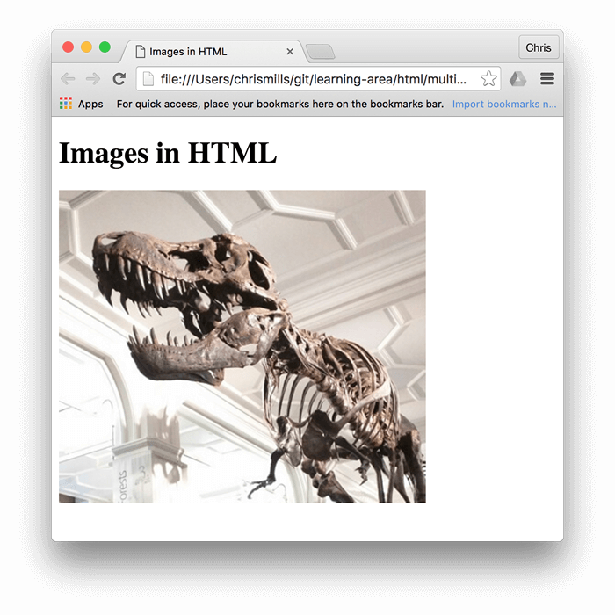
- Note: Elements like <img> and <video> are sometimes referred to as replaced elements. This is because the element's content ,and size, is defined by an external resource (like an image or video file), not by the contents of the element itself.

- Note: You can find the finished example from this section running on Github (see the source code too.)

Alternative text
The next attribute we'll look at is alt. Its value is supposed to be a textual description of the image, for use in situations where the image cannot be seen/displayed. For example, our above code could be modified like so:
  - <img src="images/dinosaur.jpg"
  - alt="The head and torso of a dinosaur skeleton;
  - it has a large head with long sharp teeth">
The easiest way to test your alt text is to purposely misspell your filename. If for example our image name was spelt dinosooooor.jpg, the browser wouldn't display the image, and display the alt text instead:
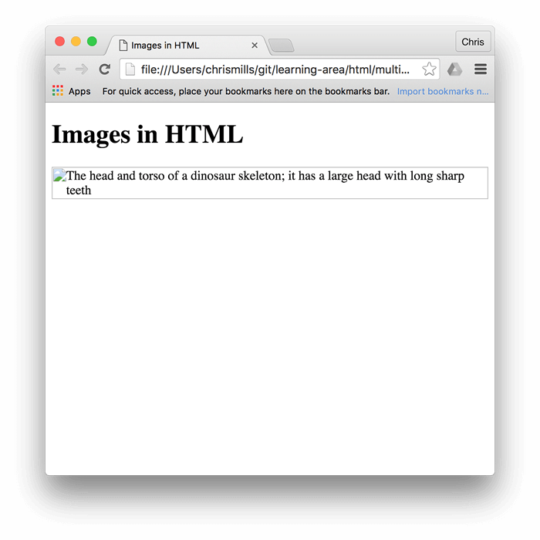
So, why would you ever see or need alt text? It can come in handy for a number of reasons:
- The user is visually impaired, and using a screen reader to read the web out to them. In fact, having alt text available to describe images is useful to most users.
- As described above, you might have spelt the file or path name wrong.
- The browser doesn't support the image type. Some people still use text-only browsers, such as Lynx, which alternatively displays the alt text of images.
- You may want to provide text for search engines to utilize. For example, search engines can match alt text with search queries.
- Users have turned off images to reduce data transfer volume and distractions. This is especially common on mobile phones, and in countries where bandwidth is limited and expensive.
What exactly should you write inside your alt attribute? It depends on why the image is there in the first place. In other words, what you lose if your image doesn't show up:
- Decoration. If the image is just decoration and isn't part of the content, add a blank alt="". For example, a screen reader doesn't waste time reading out content that is no core need to the user. Decorative images don't really belong in your HTML. CSS background images should be used for inserting decoration, but if it is unavoidable, alt="" is the best way to go.
- Content. If your image provides significant information, provide the same information in a brief alt text. Or even better, in the main text which everybody can see. Don't write redundant alt text. How annoying would it be for a sighted user if all paragraphs were written twice in the main content? If the image is described adequately by the main text body, you can just use alt="".
- Link. If you put an image inside <a> tags, to turn an image into a link, you still must provide accessible link text. In such cases you may, either, write it inside the same <a> element, or inside the image's alt attribute. Whatever works best in your case.
- Text. You should not put your text into images. If your main heading needs a drop shadow, for example, use CSS for that rather than putting the text into an image. However, If you really can't avoid doing this, you should supply the text inside the alt attribute.
Essentially, the key is to deliver a usable experience, even when the images can't be seen. This ensures all users are not missing any of the content. Try turning off images in your browser and see how things look. You'll soon realize how helpful alt text is if the image cannot be seen.
- Note: For more information, see our guide to Text Alternatives.

Width and height
You can use the width and height attributes, to specify the width and height of your image. You can find your image's width and height in a number of ways. For example on the Mac you can use Cmd + I to get the info display up for the image file. Returning to our example, we could do this:
- <img src="images/dinosaur.jpg"
- alt="The head and torso of a dinosaur skeleton;
- it has a large head with long sharp teeth"
- width="400"
- Height="341">

This doesn't result in much difference to the display, under normal circumstances. But if the image isn't being displayed, for example, the user has just navigated to the page, and the image hasn't yet loaded, you'll notice the browser is leaving a space for the image to appear in:
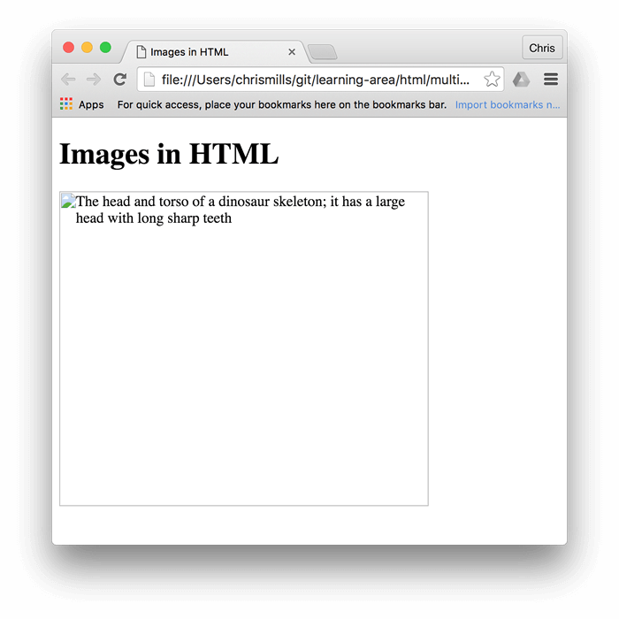
This is a good thing to do, resulting in the page loading quicker and more smoothly.
However, you shouldn't alter the size of your images using HTML attributes. If you set the image size too big, you'll end up with images that look grainy,fuzzy, or too small, and wasting bandwidth downloading an image that is not fitting the user's needs. The image may also end up looking distorted, if you don't maintain the correct aspect ratio. You should use an image editor, to put your image at the correct size, before putting it on your webpage.
- Note: If you do need to alter an image's size, you should use CSS instead.
As with links, you can also add title attributes to images, to provide further supporting information if needed. In our example, we could do this:
      - <img src="images/dinosaur.jpg"
  - alt="The head and torso of a dinosaur skeleton;
  - it has a large head with long sharp teeth"
  - width="400"
- height="341"
- title="A T-Rex on display in the Manchester University Museum">

This gives us a tooltip, just like link titles:

Image titles aren't essential to include. It is often better to include such supporting information in the main article text, rather than attached to the image. However, they are useful in some circumstances; for example, in an image gallery when you have no space for captions.

Active learning: embedding an image
It is now your turn to play! This active learning section will have you up and running with a simple embedding exercise. You are provided with a basic <img> tag; we'd like you to embed the image located at the following URL:
https://raw.githubusercontent.com/mdn/learning-area/master/html/multimedia-and-embedding/images-in-html/dinosaur_small.jpg
Earlier we said to never hotlink to images on other servers, but this is just for learning purposes, so we'll let you off this one time.
We would also like you to:
- Add some alt text, and check that it works by misspelling the image URL.
- Set the image's correct width and height (hint; it is 200px wide and 171px high), then experiment with other values to see what the effect is.
- Set a title on the image.
If you make a mistake, you can always reset it using the Reset button. If you get really stuck, press the Show solution button to see an answer:
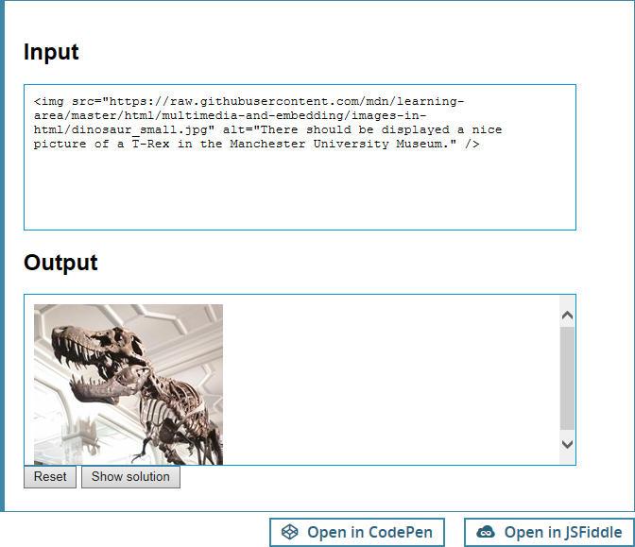

Annotating images with figures and figure captions
Speaking of captions, there are a number of ways that you could add a caption to go with your image. For example, there would be nothing to stop you doing this:
  - <div class="figure">
  - <img src="images/dinosaur.jpg"
  - alt="The head and torso of a dinosaur skeleton;
  - it has a large head with long sharp teeth"
  - width="400"
- height="341">

- <p>A T-Rex on display in the Manchester University Museum.</p>
- </div>

This is ok. It contains the content you need, and is nicely stylable using CSS. But there is a problem here: there is nothing that semantically links the image to its caption, which can cause problems for screen readers. For example, when you have 50 images and captions, which caption goes with which image?
A better solution, is to use the HTML5 <figure> and <figcaption> elements. These are created for exactly this purpose: to provide a semantic container for figures, and clearly linking the figure to the caption. Our above example, could be rewritten like this:
  - <figure>
  - <img src="images/dinosaur.jpg"
  - alt="The head and torso of a dinosaur skeleton;
  - it has a large head with long sharp teeth"
  - width="400"
  - height="341">

  - <figcaption>A T-Rex on display in the Manchester University Museum.</figcaption>
  - </figure>

The <figcaption> element tells browsers, and assistive technology, that the caption describes the other content of the <figure> element.
- Note: From an accessibility viewpoint, captions and alt text have distinct roles. Captions benefit even people who can see the image, whereas alt text provides the same functionality as an absent image. Therefore, captions and alt text shouldn't just say the same thing, because they both appear when the image is gone. Try turning images off in your browser and see how it looks.
A figure doesn't have to be an image. It is an independent unit of content that:
- Expresses your meaning in a compact, easy-to-grasp way.
- Could go in several places in the page's linear flow.
- Provides essential information supporting the main text.
A figure could be several images, a code snippet, audio, video, equations, a table, or something else.

Active learning: creating a figure
In this active learning section, we'd like you to take the finished code from the previous active learning section, and turn it into a figure:
- Wrap it in a <figure> element.
- Copy the text out of the title attribute, remove the title attribute, and put the text inside a <figcaption> element below the image.
If you make a mistake, you can always reset it using the Reset button. If you get really stuck, press the Show solution button to see an answer:
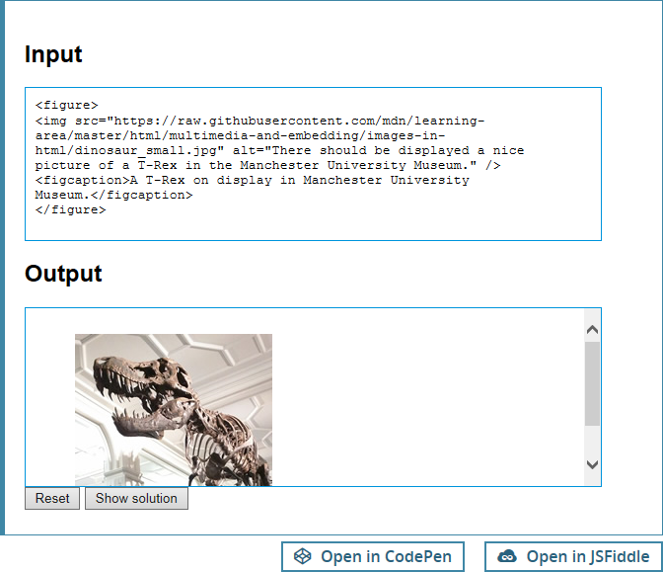

CSS background images
You can also use CSS to embed images into webpages (and JavaScript, but that's another story entirely). The CSS background-image property, and the other background-* properties, are used to control background image placement. For example, to place a background image on every paragraph on a page, you could do this:
    - p {
    - background-image: url("images/dinosaur.jpg");
    - }

The resulting embedded image, is arguably easier to position and control than HTML images. So why bother with HTML images? As hinted to above, CSS background images are for decoration only. If you just want to add something pretty to your page to enhance the visuals, this is fine. Though, such images have no semantic meaning at all. They can't have any text equivalents, are invisible to screen readers, etc. This is HTML images time to shine!
Summing up: if an image has meaning, in terms of your content, you should use an HTML image. If an image is purely decoration, you should use CSS background images.
- Note: You'll learn a lot more about CSS background images in our CSS topic.
That's all for now. We have covered images and captions in detail. In the next article we'll move it up a gear, looking at how to use HTML to embed video and audio in web pages.

CSS basics
Cascading Stylesheets (CSS) is the code that you use to style your website. For example, do you want the text to be black or red? Where should content be drawn on the screen? What background images and colors should be used to decorate your website? CSS basics takes you through what you need to get started.

JavaScript basics
JavaScript is the programming language that you use to add interactive features to your website — for example: games, things that happen when buttons are pressed or data is entered in forms, dynamic styling effects, animation, and much more. JavaScript basics gives you an idea of what is possible with this exciting language, and how to get started.

Publishing your website
Once you have finished writing the code and organizing the files that make up your website, you need to put it all online so people can find it. Publishing your sample code describes how to get your simple sample code online with minimum effort.

How the web works
When you access your favorite website, a lot of complicated things happen in the background that you may not know about. How the web works outlines what happens when you view a webpage on your computer.

